DIT Analysis Workflow

# Step 1. Radar Cross Section

* Prerequisites: MATLAB and [Antenna Toolbox](https://au.mathworks.com/help/antenna/index.html?s_tid=CRUX_lftnav)
* Open and run the MATLAB script **RCS_Calculator_2.mlx** (based [on this workflow](https://au.mathworks.com/help/antenna/ref/rcs.html)) **-** ensure that the working directory is set to the same location as this file (use >> pwd)
* At the command prompt, enter the dimensions of the satellite  
  - can be either parametric rectangular prism, cylinder, or STL file (the ‘ ’ are required)  
  - Note: the X direction in this analysis points along the Nadir direction
* The script will generate a 3D mesh of the model, save it as an STL file and load it.
* If you select the STL file, it will skip this first step, and load in the file directly.

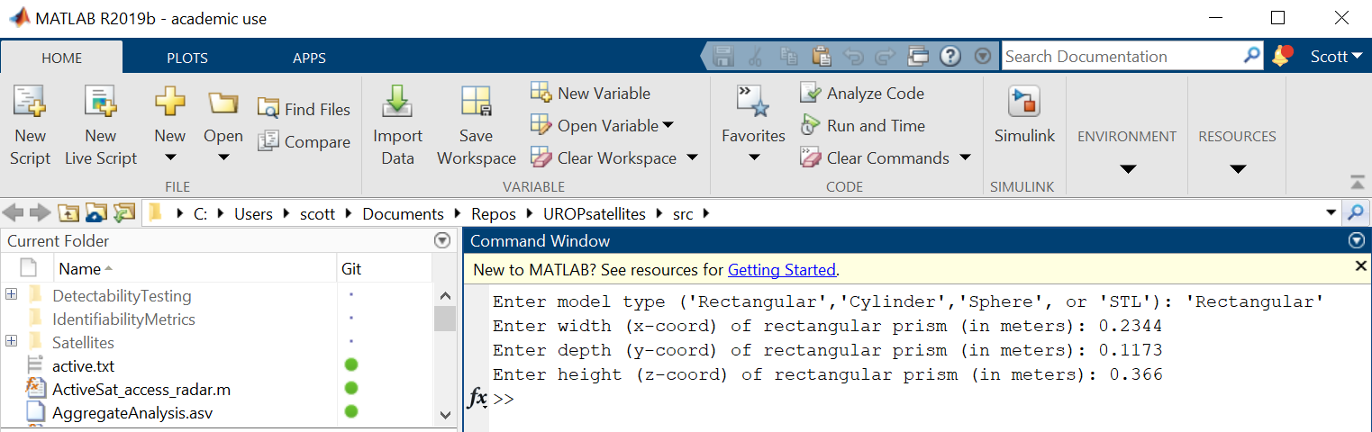

* The Script will then sweep over azimuth angles around the x axis, and compute the radar cross section at each angle. You should see a progress bar. Pg 25 of [this document](http://faculty.nps.edu/jenn/ec4630/rcsintroductionv2.pdf) describes the geometry of azimuth angles (though they use z as pointing up, whereas MATLAB uses x).
* Once the script has finished, you should see two plots  
  - the mesh of the geometry  
  - a polar plot showing the RCS at each azimuth angle (units in dBsm)

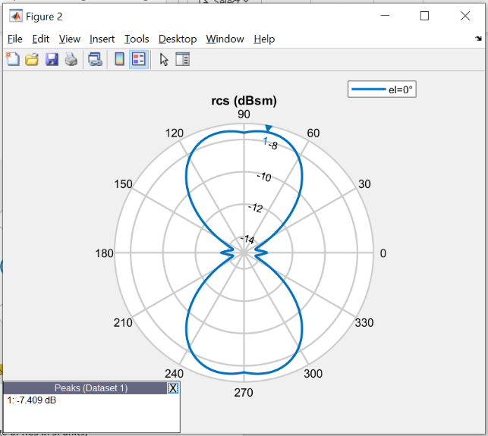

* The script will print out two average measures of the RCS  
  a) The Power-averaged RCS  
  b) The Decibel-averaged RCS

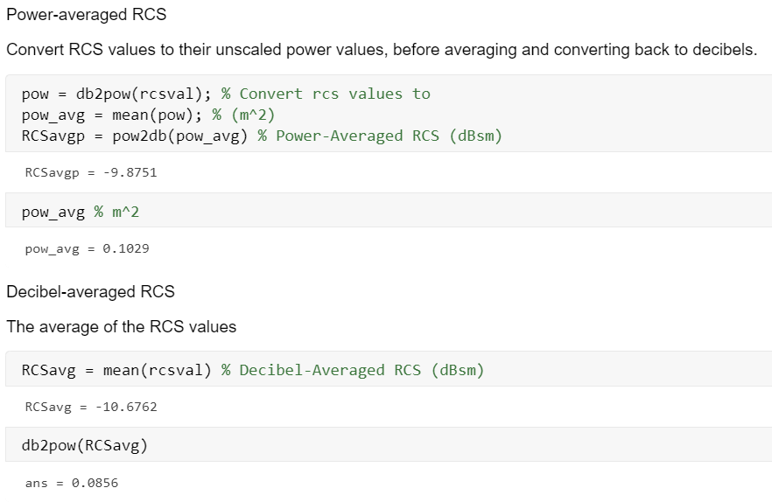

* Take a note of these values and select the highest RCS in m^2 to use  
  - E.g:

Peak = -7.409 dB  
Power-averaged RCS = -9.8752 dBms == 0.1029 m^2 (average of RCS in SI units)  
Decibel-averaged RCS = -10.6762 dBsm == 0.0856 m^2 (average of RCS in decibels)

(Selected higher estimate)

RCS = 0.1029 m^2

* NOTE: Larger satellites with size of 1-10 m may produce very large RCS values (100’s of meters)  
  - this is to be expected, as RCS is dependent on the wavelength/frequency of the radar  
  - we are using a frequency of 450 MHz  
  - the values match up with analytical predictions of RCS for simple geometric objects   
  - [this document](http://www.tscm.com/rcs.pdf) has equations for flat plate and sphere

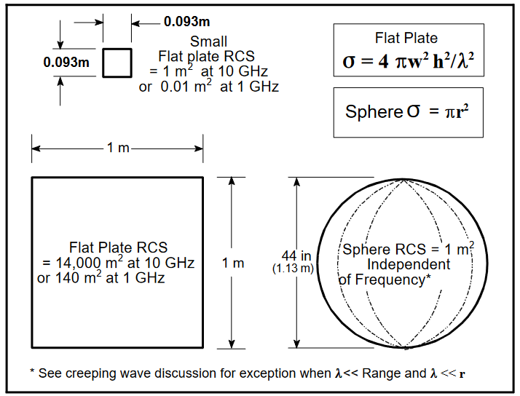

# Step 2. STK Scenario

* Open STK  
  - if your license requires you to be on a VPN, you should connect before opening
* Click Open Scenario and open the **DetectabilityTesting.sc** file
* **Note**: Before this, you should copy the entire DetectabilityTesting folder from the github repo into a new folder. This way if you save any changes to the scenario, you have the original copy you can use to replace it.
* The template scenario should have 7 ground stations – these are the stations used for the Radar and Optical **Detectability analysis**. The 49 stations used for the **Trackability analysis** are added programmatically by the script.

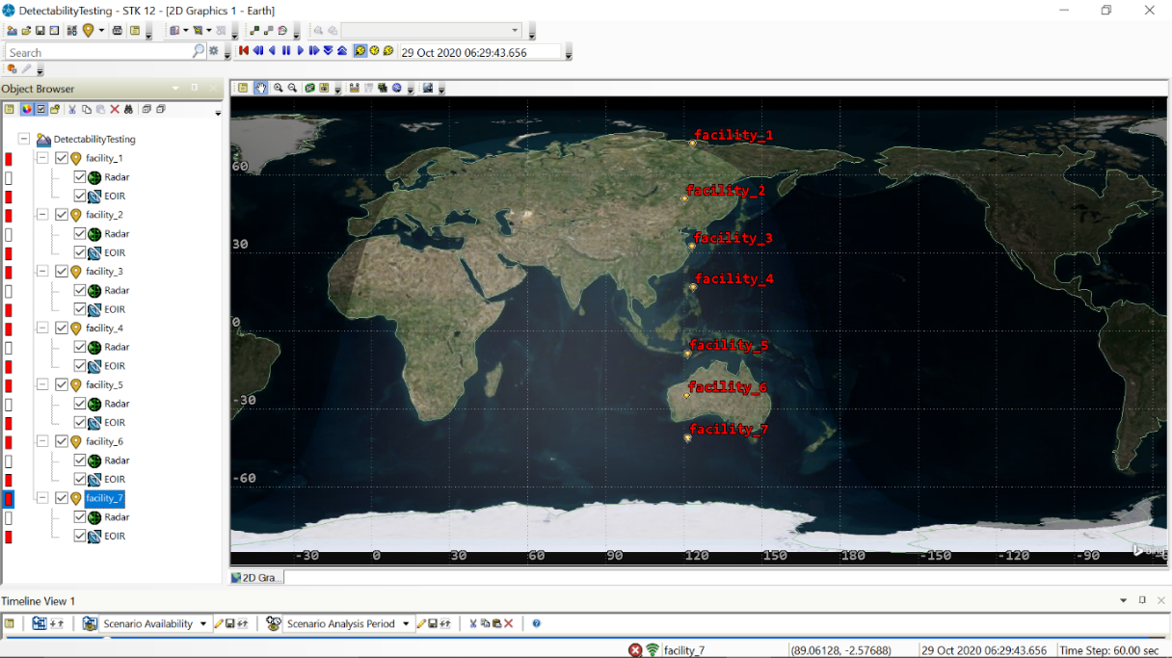

## Run the DT.py Script

* Run the DT.py script. This can be done either  
  a) Through an IDE like Spyder; or  
  b) Run through the terminal  
   >> cd ..\path\to\DT.py  
   >> python DT.py
* The user will be prompted to select either an existing catalogued satellite, or enter the orbital elements of a new satellite  
  - the first option does not currently work, as it requires access to ASTRIAGraph  
  - select option 2 and enter the requested orbital elements, and physical properties including the dimensions, radar cross section (in m^2), and reflectance (default is 17.5%).
* Orbital Elements  
  - Semi-major axis (km), Inclination (deg), Eccentricity, Right Ascension of Ascending Node (deg), Argument of Periapsis (deg)
* Physical Parameters  
  - The height, width, and depth of the satellite for a box model for use in the STK EOIR module  
  - Satellite height is along Nadir direction, other dimensions are perpendicular to Nadir  
  - Satellite reflectance also used in EOIR module (if unknown, use default 17.5%)  
  - RCS is the radar cross section in m2 determined from the first step

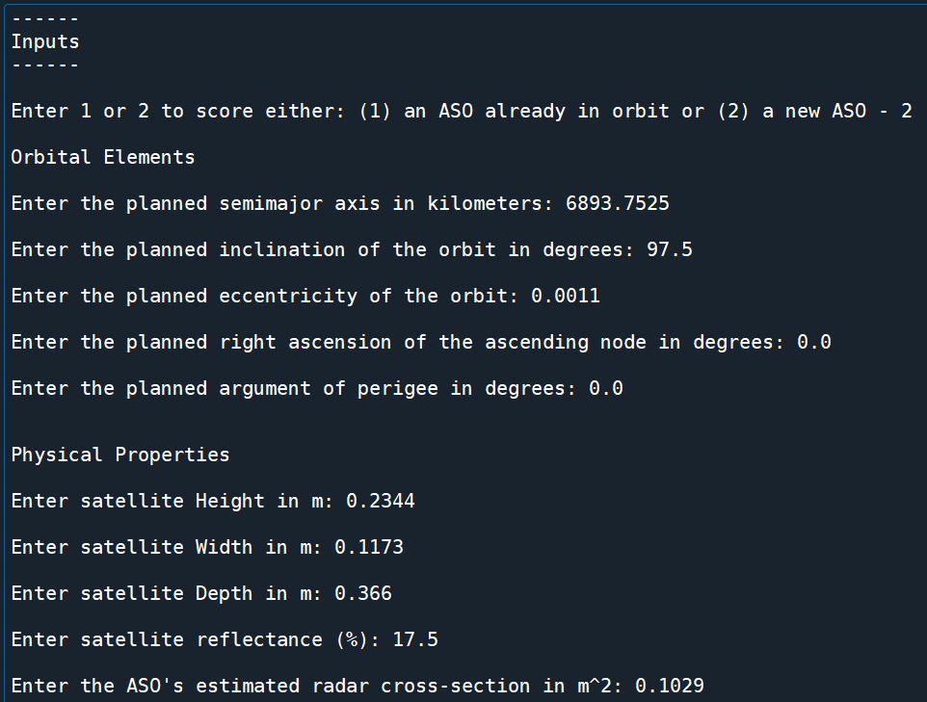

* The script will create a new satellite object in the scenario, and compute the access from the 7 radar ground stations. You should see these accessible ground traces be highlighted in STK.
* The script will also print out the results of the radar trackability

* Next, the script will one-by-one add the 49 ground stations used for the Trackability analysis
* It will then remove them one-by-one. This whole process may take a few minutes.

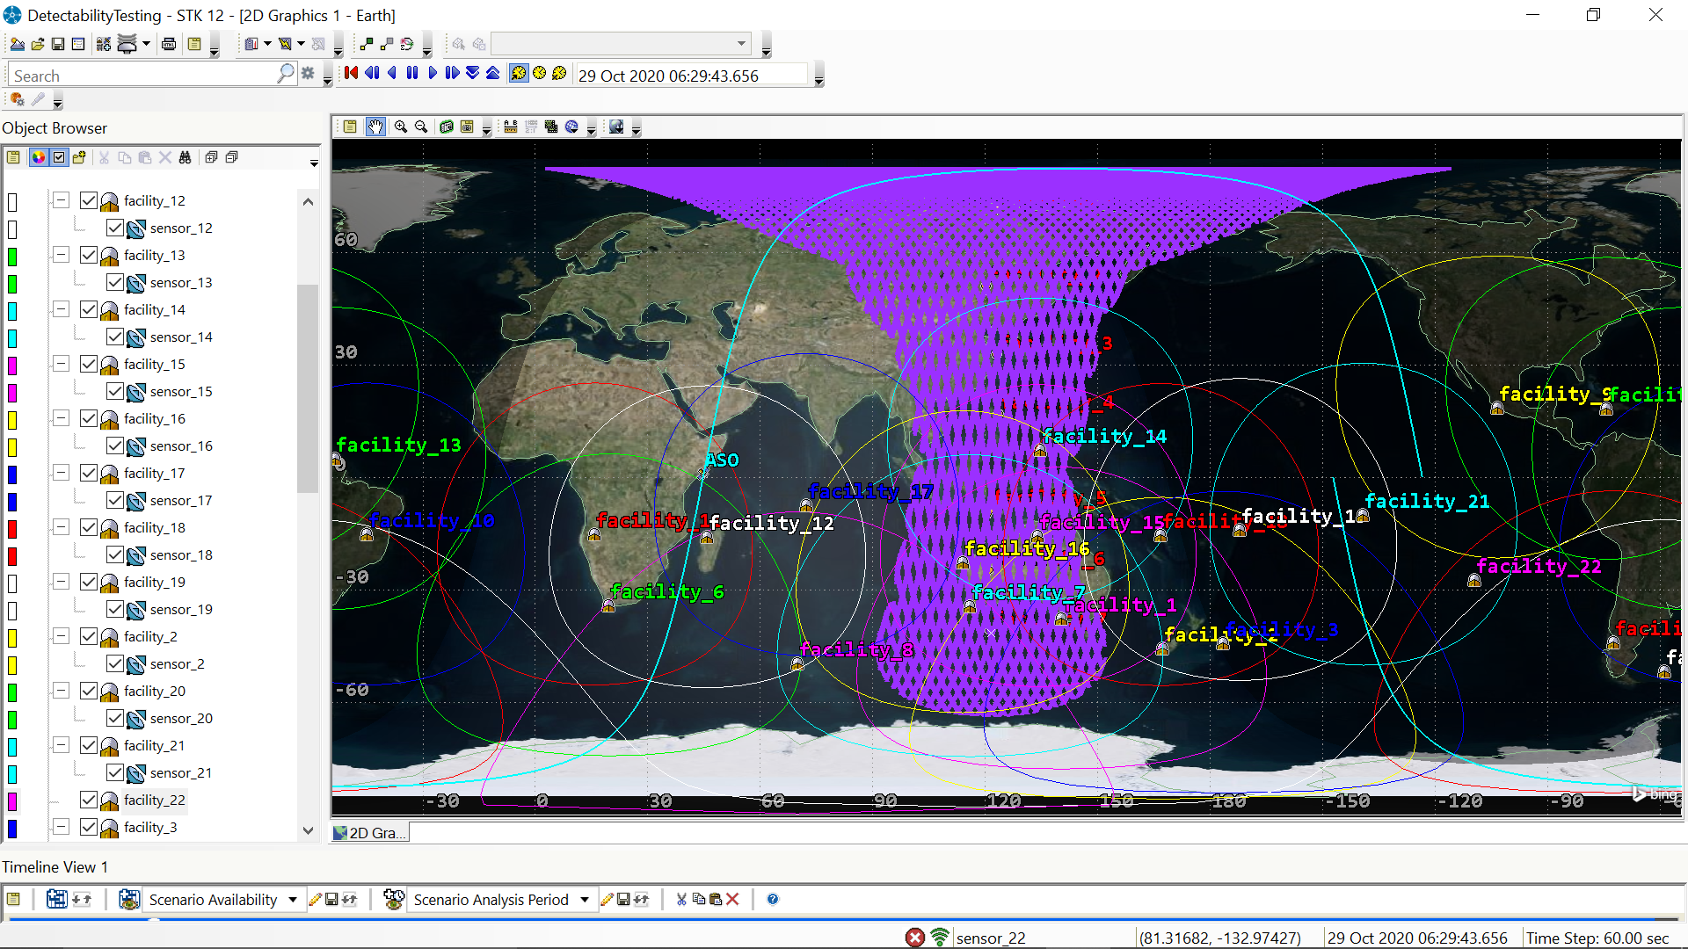

* At the end of the analysis, the 7 Detectability stations will remain in the scenario
* The outputs for the Radar Detectability, Radar Trackability, and Optical Trackability will be printed to the terminal
* The Radar Detectability has only a single score in the last column
* The Radar and Optical Trackability analysis has three metrics. The average of these three scores is printed below each dataframe.
* The Optical Detectability analysis takes some time. It uses the STK API interface to generate an EOIR report between the satellite and the ground station that has the longest visible access period. The results generate a plot of the visual magnitude over time, and print out the average visual magnitude (such that V < 15 mag).
* The details of these should be copied to a document for reference.

